2018 Community & Economic Development Annual Review

According to the International Economic Development Council, no single definition incorporates all of the different strands of economic development. Typically, economic development can be described in objectives. These are most commonly described as the creation of jobs and wealth and the improvement in the quality of life. Economic development can also be described as a process that influences the growth and restructuring of an economy to enhance the economic well-being of a community.
The City of Bluefield has been impacted for many years with the economic downturn in the coal industry that Southern West Virginia and the surrounding region has faced. Most of the issues are outside of the city’s control, as they are controlled at the state and federal levels. City leadership is implementing a proactive and aggressive approach to plan for the future of the community. A focus of partnering with existing businesses while attracting new business is central to the plan. Other strategies include encouraging entrepreneurship, diversification of the local economy, attracting new industry and constant involvement in workforce development and regional initiatives.
For many decades, the number one export from the Bluefield Region has not been coal, gas or timber, but rather our youth. We have educated and exported many of our children to other regions where they can find better employment opportunities. This trend must be reversed.
In April 2015, the City of Bluefield’s Board of Directors created a Community & Economic Development Department (CED). Since then, the CED has taken a three-prong approach to economic growth in the City and region.

- To support existing business and industry to help them diversify and grow. This is done through a Business Retention & Expansion Program.
- To cultivate entrepreneurship and innovation, especially through the Commercialization Station.
- To attract new industry, especially in the “TEAM” sectors. TEAM stands for Technology, Energy, and Advanced Manufacturing.

Business Retention & Expansion Program

Business retention and expansion is a vital part of economic development. While attracting new businesses, it is also important to assist existing businesses with their needs and obstacles. The retention and expansion program will help the community to understand local business needs through relationship building, accurate knowledge, and identifying available sites and facilities for expansion so that businesses stay, grow, and become more committed to the community.
Training/Workshops
The CED partnered with several organizations, including WV Small Business Development Center (SBDC), Robert C. Byrd Institute (RCBI), and WVU Manufacturing Extension Partnership (MEP0, to host various training and workshops for local businesses and individuals. These trainings and workshops include but not limited to:
  - WVU MEP Time Management
  - WVU MEP Inventory Management/Time Study/Process Evaluation
  - Business Fundamentals Workshops with WVSBDC
  - RCBI Exporting Training
  - RCBI HUBZone Workshop
  - Entrepreneurial Training taught by Jim Flowers from VT Knowledge Works
  - Opportunity Zone Training
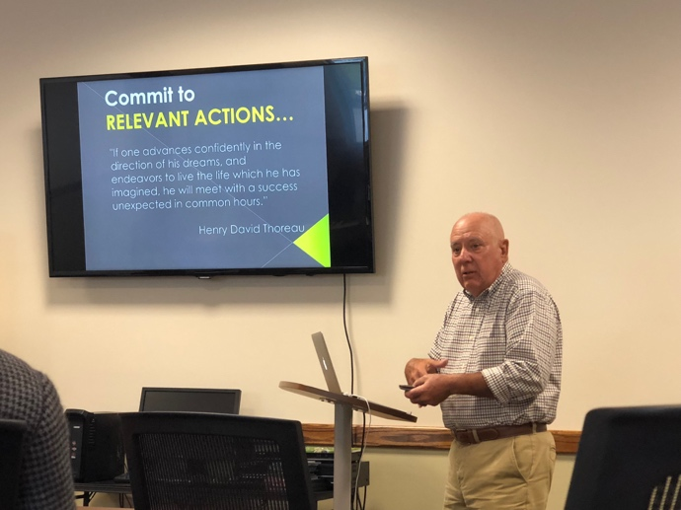
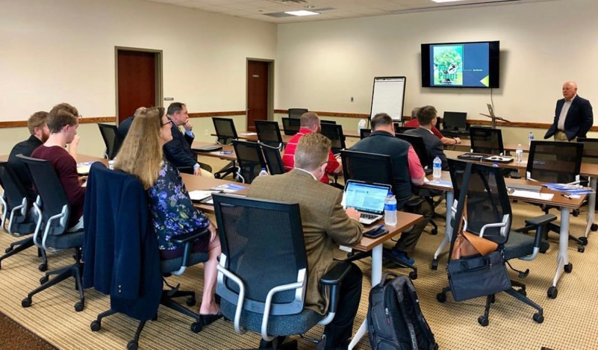

Marketing

- Video Marketing Program – The CED will produce a short marketing video for any business located within the City that are current on their fees and taxes. The service is free to the business and is a partnership between the CED and the business to help them grow. The business can use the video to market themselves while the CED uses the video to market the businesses and the City. Many of the videos are on the landing page of the www.mybluefield.org website.
- MyBluefield App – The CED applied for and received grants to create the MyBluefield App which went live on August 31 on the IOS and Andriod Platforms. A billboard advertising the MyBluefield App was installed on September 15 on the City’s property on US 52. The goal of the App is to market the City, the local businesses, and events to tourists, local college students, and the region.
- Expanded Social Media – With the rapid growth of video marketing and other platforms, the City has grown 49% of its following since last year. In the fall, the CED created a Facebook group for business owners as a way of communication, collaboration, and promotion. The City just expanded the Social Media Platform to include a CED page on Linkedin.
- The CREATE Opportunity Resource Guide is a digital brochure on the www.mybluefield.org website and is a resource for entrepreneurs, startups, and existing companies. Hard print copies are available to mail to prospective industries.

Small Business Saturday
The City participated in its fourth year in Small Business Saturday. The event was started by American Express in 2010 and is held on the Saturday after Thanksgiving to support small businesses. To celebrate the event, the CED had four contests and a pop-up shop in the Historic Bank Lobby. The CED advertised the event with a joint marketing effort with the participating businesses. There were 26 participating businesses, many of whom reported that they had a prosperous day. An appreciation breakfast was hosted at the Bluefield Arts Center for the businesses the morning of Small Business Saturday to kick off the event.
Testimonial - “This year’s Small Business Saturday was a huge success. We had more customers today at Fantastic Finds than we ever had since we opened in 2009. I’ve heard similar success stories from other downtown enterprises. Thanks for taking the initiative. Keep up the good work.” Quote from Craig Hammond

Entrepreneurship
“Economic Gardening is an entrepreneurial approach to economic development that seeks to grow the local economy from within. ... Its premise is that local entrepreneurs create the companies that bring new wealth and economic growth to a region in the form of jobs, increased revenues, and a vibrant local business sector.” (Definition from the ICMA).
- In celebration of National Entrepreneurship Week, the CED hosted the 2nd Annual Meet the Millennials on February 22, 2018, where over 60 college students and aspiring entrepreneurs met together with 10 business owners to hear about their journey as a business owner. The event was created as a networking opportunity and to pass on lessons learned by existing successful business owners to the next generation of entrepreneurs.
- Business and Baseball - The CED set up a booth at the Blue Jays Baseball game at Bowen Field on July 3rd to talk to attendees about starting a business and business opportunities in Bluefield.
- CREATE Opportunity Initiative – There are sixteen colleges and universities within 50 miles of the City of Bluefield. The CED has been working to establish partnerships with each. One of the goals is to use the “pipeline of talent” from the colleges and universities to attract companies into the area while supporting the existing workforce needs of existing businesses. In 2018, the CED Director and/or staff visited the following campuses for meetings, Bluefield State College, Concord University, Valley College, American National University, VA Tech, and Bluefield College. The CED partnered with the Landscape Architecture Program at VA Tech in January 2018 where 40 students did class projects on development ideas in the City.
- The CED met with the Emerging Leaders at Bluefield State College to share services and resources the department offers.
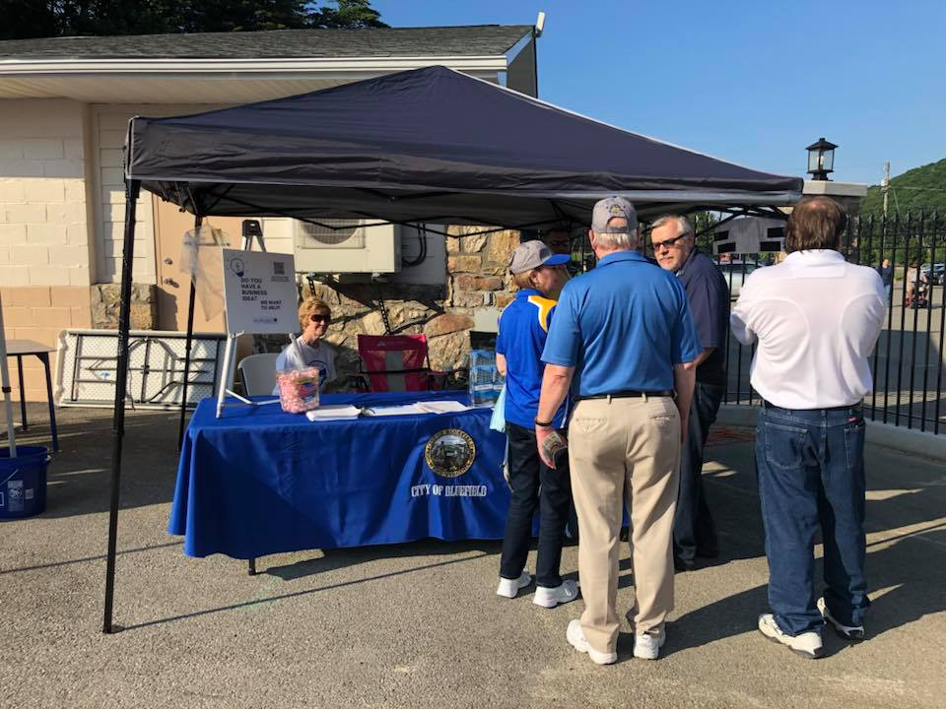
Attracting New Industry
- Commercialization Station Groundbreaking – August 20
Located at 1642 Bluefield Ave., the Commercialization Station is a 60,000 SF mixed-use incubator focusing on manufacturing. Once renovations are completed early spring of this year, there will be 5 bays, each approximately 8,000-10,000 SF with 17’ ceiling height for business incubation. This project is also part of the CED’s entrepreneurial efforts.
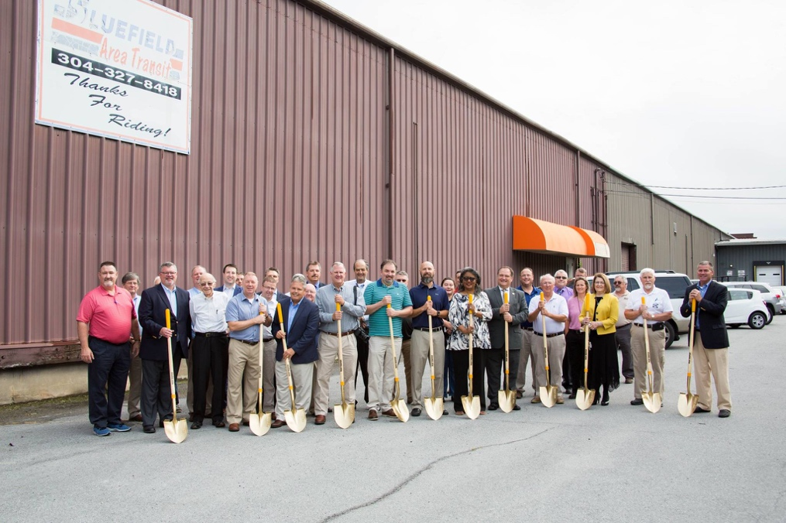

Data Analysis
Why is data so important? According to the University of North Carolina’s School of Government,
“Because decision making in the modern world is based on data. Statistical analysis offers the most objective, informed way to analyze a situation and project the impact of different courses of action. This is certainly true for community economic development. Decision makers in both the public and private sectors rely on data to make decisions. Businesses leverage numbers from the Federal, State, and local government agencies, to decide where to invest their resources. From simple population facts to more sophisticated surveys of household expenditures, data is the best way for companies to forecast revenues and costs under several circumstances. These projections ultimately drive all major business decisions. Similarly, government agencies and public leaders utilize data to inform public policy. State and Federal governments often allocate resources according to the population or economic statistics. Regulations and laws dealing with economic development are analyzed using a cost-benefit analyses, which also draw on data. At every level, economic development decisions are driven by numbers. Good data and statistical information helps public and private decision makers to invest in a particular project by shedding light on the project’s likelihood for success.”
The use of data in decision making, especially when coupled with the power of a robust GIS, is paramount to planning and forecasting in economic development. The CED has a very qualified GIS Analyst that can now “mine data” through Esri’s Community Analyst package as well as other sources. The data can help us develop “cluster analysis” and target markets which can help us market the City in a more professional fashion as well as help us make decisions on which are the best companies to try and attract to the City.

- Other Grants
  - FLEX-E Grant to pay for the services of technology consultants to develop a plan to attract technology companies to Bluefield. The project budget is $10,500 with $8,500 being a grant from the State of WV. One of the technology consultants is Ms. Karen Jackson the former Secretary of Technology for the Commonwealth of VA.
  - $1 Million EDA Grant for Exit 1 Development
  - AEP Edge Grant for Marketing Opportunity Zone. The total grant award was $15,000.
  - Capacity Development Grant for the Blueprint Community Team and updating the Blueprint Plan. The total grant is for $25,000 from FHLBank Pittsburgh’s Blueprint Communities® initiative. The City procured the services of Diane Lupke & Associates to assist with the project. Ms. Lupke was in Bluefield on December 10th – 12th to start the project and will return to Bluefield in the next few months to complete the project. (Ms. Diane Lupke, CEcD, FM, is located in Newton, Wisconsin and has more than twenty-five years of experience in the management of, and program and policy development for, all aspects of community economic development. She has provided technical assistance to more than 75 cities, states, and non-profit organizations regarding governance, strategic planning, market analysis, work force development, job creation, and neighborhood revitalization. Ms. Lupke is an authority on the use of tax credits and other special tools for development).

- Opportunity Zone - The CED took the lead and submitted an application on behalf of the Cities of Bluefield and Princeton and Mercer County for three census tracts. Tracts 23 & 24 were chosen and we received the designation. There are over 8,700 Opportunity Zones in the US. Too often the region does not take advantage of programs like this because many times they are not aware of the programs and their benefits. We have been working to change this by hosting local training events. Our goal is to use the Opportunity Zone as a catalyst for development within the census tracts and attract outside investment into the area.

Other Key Initiatives/Projects
- In the 21st century economy, broadband is vital for economic growth. The broadband needs to be redundant and affordable. The City of Bluefield received a grant from the Shott Foundation to create a wireless network in the Downtown and along Bluefield Avenue that will have speeds in excess of 1 Gig. The City procured the services of Gigabeam Networks to build the wireless system and the new service will be available in the next few weeks giving customers various choices for broadband service. The City of Bluefield will be the first Giga-City utilizing 5G technology in the region.
- Wayfinding/Signage Study – The City procured the services of Hill Studio to develop the study. New signage will be installed in 2019 to help tourists and visitors find their way while visiting the City. The Blueprint Communities Team participated in the project.
- Bluefield State College Research & Development Center now hosts a satellite office for the Robert C. Byrd Institute which offers services to business in the region.
- Rebecca Kasey was hired full time as the Business Operations and Marketing Coordinator for the CED.
- Jim Spencer was appointed to Mercer County Development Authority in June.
- The CED has hosted consultants and prospective companies in the City in an effort to attract new industry and entrepreneurs. This is an on-going process.
- The TechConnectWV is one of the key partners with the CED and is a “non-profit coalition committed to the advancement of the innovation economy in West Virginia, focused on four technology sectors: advanced energy, chemicals and advanced materials, biosciences, and biometrics. With broad representation from private industry, the public sector, and higher education, TechConnectWV seeks to diversify the state’s economy, promote economic prosperity and create high-paying jobs.” TechConnect has created a Cybersecurity Workforce Committee for the State of WV. According to their West Virginia Cybersecurity Workforce Strategic Initiative Report,
“Job opportunities for cybersecurity professionals are growing significantly, but a large percentage is going unfilled within the United States, particularly within the military and the federal government. Such unfilled positions complicate securing the nation’s networks and may leave the United States ill-prepared to carry out conflict in cyberspace. And, this cyber shortage also poses dangers to critical infrastructure, our health care and banking systems, to governments of all sizes and to business large and small. According to cyberseek.org (2018) in West Virginia (WV) there are currently 872 cybersecurity job openings with a total employed cybersecurity workforce of 2,691. At the national level there are 313,735 total cybersecurity job openings with a total employed cybersecurity workforce of 715,715. These numbers will increase because, according to the Department of Labor's Bureau of Labor Statistics, the field of cybersecurity is projected to grow at a rate of 28% from present to 2026.”
TechConnectWV hosted a Coding & Cyber Summit in November 2018. The CED Director has actively participated in the Workforce Committee this past year and the Summit. The goal by participating is to find opportunities to attract technology companies to the area.
- Jim Spencer participated and was a panelist at the Broadband Networks: Tools for Economic Growth and Opportunity, a conversation hosted by Microsoft, the Brookings Institution, and Create West Virginia in June.

- The City had some new businesses open in 2018 that received support from the CED. They include but are not limited to; OnPath Graphics, Ladies & Littles Boutique, B’s Honey Baking Company, Ugly Duckling’s Reopening, Imogene & Rose Paper Studio, and No Cages Garage.

“After starting my graphic design business in 2011, I made the decision in 2016, to move to Bluefield, W.V. to be closer to family. Being new to the area, my business faced challenges in marketing and connecting with the right clients who needed my services. The Community and Economic Development team at the city of Bluefield, namely Jim Spencer, Rebecca Kasey, and Brandon Saddler helped me every step of the way. They provided strategic resources, facilitated business networking opportunities, and lent an ear when I had concerns about my business’s growth. Today, my business is thriving and is on track to sustainable success and the city of Bluefield helped me to get here.”
-Ebony Murrell, Owner of OnPath™ Graphics

